[Note: To complete this template, replace the bracketed text with your own content. Remove this note before you submit your outline.]

Report: Selling Price and Area Analysis for D.M. Pan National Real Estate Company
[Your Name]
Southern New Hampshire University

Introduction
Considering the fact that, housing prices always tend to vary in various regions, it is always contributed by certain factors and certain models which tend to explain how the variables relationship can be used to predict the change in prices. In this report, I will be providing the prediction in the housing prices based on the various properties sold and their several sizes, which is in Square feet Units. In this entire report, the Real Estate County Data of 2019 has been utilized and will be reflecting on the East North Central Region.

Representative Data Sample
Considering the first 30 samples data in the East North Region, the following are the results considering both the listing price and square feet as variables in the sample data.
Within this East North Central Region, Utilizing the data of the 30 Sample units, the following of the were the mean, standard deviation and median the of the listing price
Mean = 210,036
Median = 212,900
Standard Deviation = 38147.17
Within this East North Region, utilizing the data of the 30 sample units, the following were the mean, standard deviation and median of the square feet.
Mean = 1614
Median =1651
Standard Deviation =253.3147

Data Analysis
The samples from the 30 regions whose data was utilized shows a clear reflection of the national market and this is due to the numbers relation to the entire graph shown. This data from the 30 sampled regions will differ based on the pricing in various areas of the East North Region. However, if considering the relations of the median, standard deviation and the mean in relation to graph indicting the national statistics, the numbers tend to reflect the some similarities in their standard deviation, median and mean. Considering samples from one region of the country tend to be a reflective of the market nationally within the similar population. Taking the samples which was provided in the excel, utilizing the =RANDBETWEE () command, and I was able to keep the sample to be much random. This kind of command generates varying samples within the population and in the excel sheet, every rows of the data provided were numbered from (1-1005), although I used number (6-30) to be able to generate the random sample of the East North Region.

Scatterplot
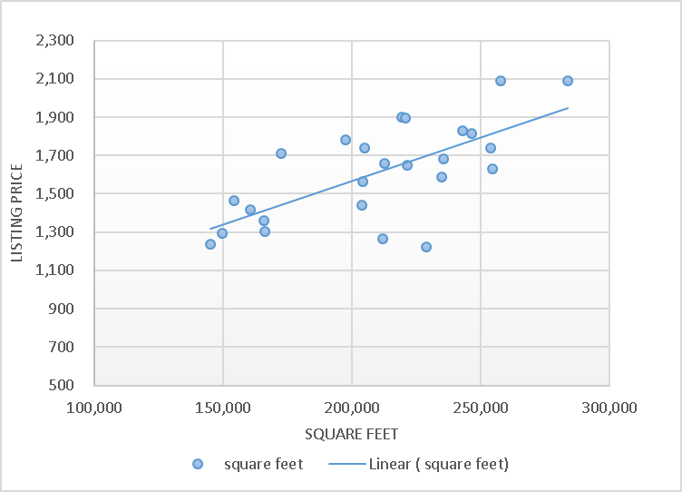
The Pattern
Y which is the assumed variable would be the listing price of the various houses and the X which is the predictor variable should be the Square Feet and doing this, we see an increasing trend, which means, there exist appositive relationship between the two variables (X and Y). The use of the linear graph suites best when it comes to the modeling of the sampled data. If you had a 1,800 square foot house, using the linear regression equation in the graph, the price will be 668.64. Considering the entire number of samples, 17 and 24 are both in the fourth quartile in the listing price and this means the absent of outlier.

